Department of YOuth Rehabilitation Services

**Strategic Priorities for** Fiscal Years 2013-14

Z:\Misc\DYRS Logo.tif

Table of Contents

The Process of Strategic Prioritization 1

Mission & Theory of Change 2

Understanding the Strategic Priorities Document 4

STRATEGIC PRIORITIES FOR FISCAL YEARS 2013-14 5

Integrating the Strategic Priorities into DYRS’s Work 6

Conclusion 7

# The Process of Strategic Prioritization

In June, 2012, DYRS embarked upon a strategic prioritization process to guide the agency for Fiscal Years 2013-14. For the effort, DYRS recruited a multi-disciplinary, cross-agency team to work side-by-side with external stakeholders. The participants were tasked with evaluating the agency’s current effectiveness in meeting its mission, and with making recommendations for how DYRS’s resources could be more effectively targeted. Each member of DYRS’s executive team participated, as did representatives from line staff, each level of agency management, and every agency division. DYRS also benefited from the expertise of thought leaders in juvenile justice, innovators at sister agencies, and vocal community advocates. All told, forty individuals, each with a unique perspective on DYRS’s work, contributed to this strategic prioritization.

|  |
| --- |
| **By conducting a ‘strategic planning sprint’ over a compact timeframe, DYRS developed the capacity to re-evaluate its policies, practices and initiatives regularly in order to ensure that we are making the greatest possible impact on improving public safety while giving court-involved youth the best opportunity to become more productive citizens.** |

The planning process took place in three stages. At the initial meeting, the **Strategic Planning Steering Committee** convened to launch the initiative. The group reviewed the agency’s mission and theory of change, then worked to articulate the agency’s vision for the future: what will the world look like when we know we’ve succeeded? Finally, the members of the Steering Committee were grouped into **Focus Area Sub-Committees** that were tasked with delving deeper into the three pillars of the agency’s approach: (1) **Safe Facilities, Safe Communities**,(2) **Youth Prepared to Succeed**,and (3) **Efficient and Effective Management**.

Each Focus Area Sub-Committee then selected additional members to join their group. The Sub-Committees built on the vision articulated by the Steering Committee and evaluated DYRS’s current performance to determine how effectively we are advancing the agency mission. The Sub-Committees were also asked to develop **Core Performance Measures** that will allow the agency to regularly track its progress toward achieving its mission.

After working through each of its analyses, the Sub-Committees reported back to the Steering Committee, recommending core performance measures and between eight and eleven **Strategic Focus Areas** that will maximize our impact on our mission over the next 24 months.

With the Sub-Committees’ recommendations in hand, the Strategic Planning Steering Committee reconvened to conduct a final review of the core performance measures and strategic focus areas. In reconvening, the Steering Committee turned its attention to ensuring that the sum total of the recommendations, when considered in concert, can be used to guide agency prioritization and to align the efforts of each staff member toward a unified vision for success.

**Leveraging Results-Based AccountabilityTM**

At the launch of the strategic prioritization process, DYRS engaged the *Results Leadership Group*®, to train the Steering Committee and Sub-Committee participants in the Results-Based Accountability framework for strategic planning and performance management. The lessons garnered through the RLG trainings informed the entire strategic prioritization process.

# Mission & Theory of Change

The strategic planning process begins with the agency’s mission, theory of change and vision. Together, they act to (1) establish the goals of all agency activities (2) set parameters on the scope of these initiatives and (3) provide guidance on the best means for implementation. This section first focuses on the agency’s mission and theory of change, which have been steadfast during the current administration. Together, they establish a firm starting point for the strategic discussion. From there, the Strategic Planners will work together to articulate the vision of how the world will look when DYRS’s work is complete.

## Mission

DYRS’s mission is drawn from the agency’s Establishment Act. It reads:

The mission of DYRS is to improve public safety and give court-involved youths the opportunity   
to become more productive citizens by building on the strengths of youths and their families   
in the least restrictive, most homelike environment consistent with public safety.

## Theory of Change

From its initial stages, the current DYRS administration has grounded its theory of change in the virtuous cycle of Positive Youth Justice and public safety. Rather than mutually exclusive, these goals are mutually dependent. The most reliable path to sustained public safety is to help the young people DYRS serves develop themselves into fully productive citizens. By the same token, establishing a safe environment is foundational to the sort of personal growth that we expect from these young people.

It is thus through a paired commitment to both Positive Youth Justice and public safety that DYRS is best able to meet its mission. Complimenting these two core goals, DYRS has established the third goal of effective management as the engine that will propel the completion its mission.

### Safe Facilities and Safe Communities

The first words of the agency’s mission establish public safety as a core goal for all agency activities. Each agency initiative must be focused on improving the long-term safety of the District of Columbia. Safety, though, is not just an end for DYRS. It is also a means to achieving its mission. Simply put, youth development relies on youth having a safe environment in which to grow. DYRS’s guiding principles state that “A safe environment is the foundation for a flourishing community.” This is equally true in secure placements as it is in the community-based settings. As such, promoting and maintaining safe environments for all DYRS youth is fundamental to the agency’s theory of change.

### Youth Prepared to Succeed

Helping court-involved young people develop the skills and relationships they need is DYRS’s most important long-term public safety strategy. The agency has adopted the Positive Youth Justice framework as its core evidence-based model for helping young people transition to a positive adulthood. Positive Youth Justice is derived from the broader body of research behind Positive Youth Development (PYD). The PYD principles are grounded in the philosophy that youth are assets and resources to the community, and that with the right programs, opportunities, supports, and services youth can develop to their full potential. According to the PYD principles, positive development requires youth to experience:

* Safety and structure
* A sense of belonging and membership
* Self-worth and the ability to contribute
* Self-awareness and the ability to reflect and assess
* Independence and control over one’s life
* Lasting relationships with pro-social and caring adults
* Competence and mastery

While PYD is broadly focused on the developmental needs of young people generally, Positive Youth Justice (PYJ) focuses on the specific developmental needs of young people involved in the juvenile justice system. The PYJ model adapts the traditional 40 developmental assets identified through PYD, honing them to six core developmental domains:

* **Work:** Work experience, apprenticeships, employment readiness, income and independence
* **Education:** Literacy, credentials, learning skills, career planning
* **Health:** Physical activity, diet and nutrition, behavioral health, lifestyle and sexuality
* **Relationships:** Communication skills, conflict resolution, family systems, intimacy and support
* **Community:** Civic engagement, community leadership, services, responsibility
* **Creativity:** Personal expression, visual arts, performing arts, language arts

The PYJ framework, which was published in 2010 by a team of researchers led by Dr. Jeffrey Butts at the John Jay College of Criminal Justice in New York City, also establishes two key assets for court-involved youth: (1) learning/doing; and (2) attaching/belonging.

### Efficient and Effective Management

As a public agency, DYRS is accountable for the responsible stewardship of public dollars. Beyond this responsibility, effectively managing agency resources is vital to the fulfillment of the agency’s mission. The best intentions for youth development and public safety will not get us to our goal without thoughtful program implementation, responsible use of resources, attention to best practices, and a competent, committed and properly deployed staff, to name just a few aspects of effective management.

### Integrating the 3 Components of DYRS’s Theory of Change

The three elements of DYRS’s theory of change – Positive Youth Justice, Safe Facilities & Safe Communities, and Effective Management – are designed to work in concert in advancing the agency mission. With this in mind, the strategic planning process must focus on enhancing DYRS performance across each of these areas, with an eye toward comparative strengths and weaknesses across the department.

As each of the agency’s current or potential initiatives comes under the evaluative eye of the strategic planners, it should be evaluated for its contributions to each element of the theory of change. Is it a strength-based approach that values our youth as assets to the community? Does it promote a safe atmosphere for youth and adults over the short and long term? Does it represent an efficient use of resources? Is it adequately staffed, thoughtfully designed and accountable to measurable outcomes? These are the types of questions that the Strategic Planners must ask of each DYRS initiative.

# Understanding the Strategic Priorities Document

Integrating the various initiatives requires looking at them in their totality. Are the focus areas in line with tenets of the agency’s theory of change? Are they appropriately prioritized so that they will have the largest impact on improving performance? Are they linked to clear outcome measures that will let the agency track its progress? The **Strategic Priorities for Fiscal Years 2013-14** document provides a snapshot overview of the agency’s overall approach to meeting its mission. The one-page chart lists the agency’s overarching goals, specific visions, core performance measures, and strategic focus areas. It is not comprehensive of all the important activities and initiatives that DYRS staff are involved in on a daily basis. Rather, the Strategic Priorities provide a window into where the agency thinks it has the greatest opportunities to leverage its resources to maximize its impact. It is designed to be sufficiently broad that each DYRS employee is able to see how their work contributes to the broader agency goals, and sufficiently specific to guide agency decision making and prioritization.

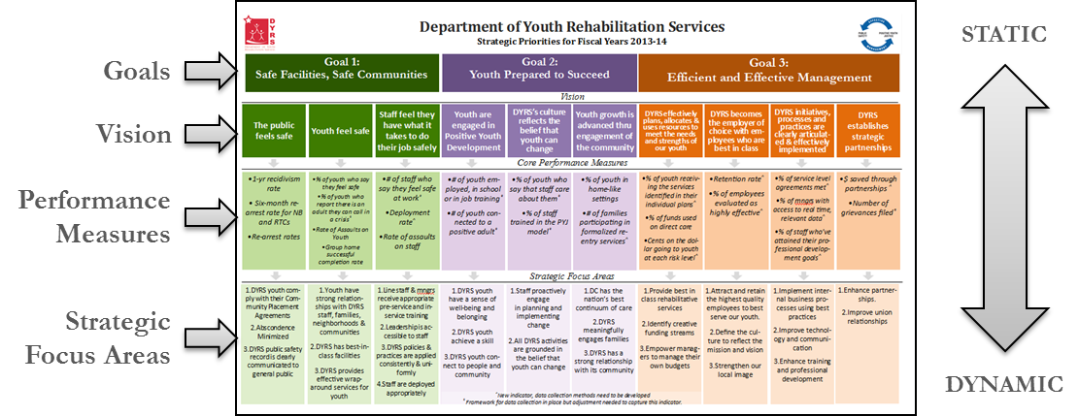

The strategic prioritization process was more compact than a traditional strategic planning process. This fact reflects the agency’s general belief that our overarching mission and approach are right – what required consideration was how to best put its approach into practice as we look forward into the next two fiscal years. The abbreviated process also provided good practice for DYRS; the strategic prioritization is not intended to be a static document to be revisited only at the end of each fiscal year. Rather, it is a dynamic tool that is meant to be revisited and amended with some regularity. By conducting an agency alignment over a short timeframe, DYRS built the capacity to regularly re-evaluate its policies, practices and initiatives to ensure that it is making the greatest possible impact on improving public safety while giving court-involved youth the best opportunity to become more productive citizens.

# STRATEGIC PRIORITIES FOR FISCAL YEARS 2013-14

# Integrating the Strategic Priorities into DYRS’s Work

The Strategic Priorities are mission oriented; they are not designed to complement a specific organizational structure, or provide each business unit with specific facts. Instead, each business unit ought to be able to identify how its work contributes to the overall mission completion. The chart below provides an example for how different portions of the Strategic Priorities document touch various parts of the agency. This chart is not comprehensive of who contributes to which goals, but rather shows how each part of the agency is important to achieving the overall goals of DYRS.

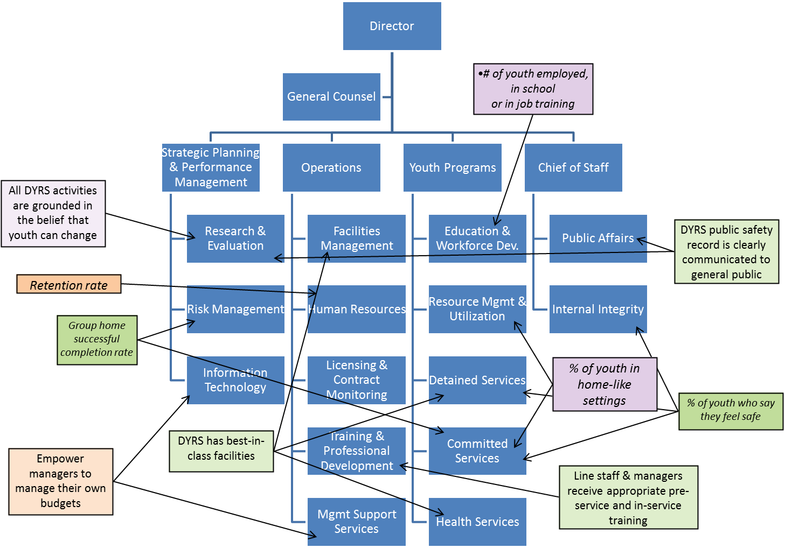

It is also important to note that while the Core Performance Measures listed in the Strategic Priorities document are valuable for the agency as a whole to measure its progress, each business unit ought to develop its own internal measures to track its unique contributions to overall agency performance. For example, the Health Services administration should set internal benchmarks for the timeliness of health screens or responses to requests for care, knowing that if it can improve these parts of its service delivery, the agency will be one step closer to having best-in-class facilities and having more youth report that staff care for them.

# Conclusion

The goal of the Strategic Prioritization is to bring all agency efforts into alignment by ensuring that everyone is working toward shared goals and the same set of outcomes. The Goals, Vision, Core Performance Measure, and Strategic Focus Areas were arrived at through a deliberative process that included staff from all levels of DYRS, as well as a diverse group of external stakeholders. The resulting document is designed to guide agency priorities for the next two fiscal years. In it, each DYRS staff member ought to be able to find his or her work reflected. And as new opportunities emerge that require decisions to be made regarding trade-offs and prioritizations, the Strategic Prioritization document should serve as a tool to aid in decision making.

As it stands, the Strategic Prioritization is a reflection of the agency’s current approach to completing its mission. Over time, the approach will change to reflect the ever-evolving context in which we do our work. The Strategic Prioritization process has served the agency well, both in helping set a road-map for success and demonstrating the process through which that roadmap can be quickly and thoughtfully amended in the future. The agency is deeply grateful for all those who contributed to this process and will strive to realize the powerful vision of an agency that protects public safety, empowers youth in their own development and is managed efficiently and effectively from top to bottom.